Dear Parent,
Researchers at the University of Birmingham are conducting the ELSA study. We are writing to you because as a parent/carer of a child aged 3-13 years, your child is invited to take part.
The ELSA study is screening children, aged 3-13 years to find out their risk of getting type 1 diabetes. This is a simple finger stick blood test, you can do at home or at your child’s school. We are offering the screening at your child’s school on 26th February 2026.
Children at high risk can be monitored and could enter research studies aiming to delay the start of type 1 diabetes. Every family who takes part in the ELSA study is helping us to understand more about type 1 diabetes.
We enclose the parents’ information leaflet for this study with this letter.

If you would like to take part or to find our more information, please visit our website or scan the QR code below. If you have any questions, please contact the ELSA study team by email, phone or on our website. If you decide you are not interested in this study, you do not need to do anything further.

Yours sincerely,
The ELSA study team

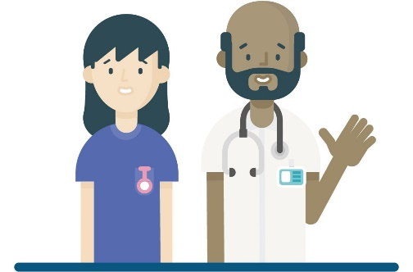

ELSA Study Team:
Website: www.elsadiabetes.nhs.uk
Phone: 0121 414 7814 (9-5pm).
Email: elsa@contacts.bham.ac.uk
Address: ELSA study team, Ground Floor, Institute of Translational Medicine, Heritage Building, Mindelsohn Way, Birmingham, B15 2TH
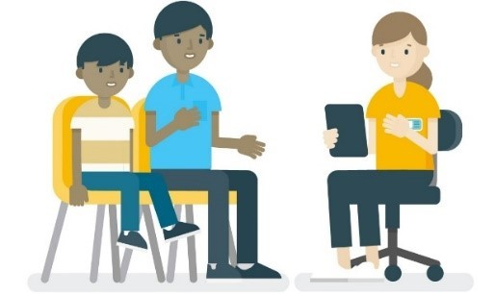
Scan to find out more:
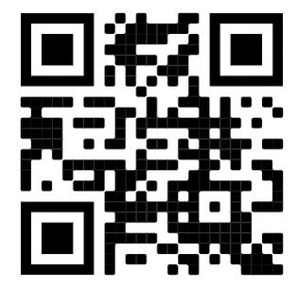
Scan to register interest:
